On the employee record on your CPQ NetSuite Backend.
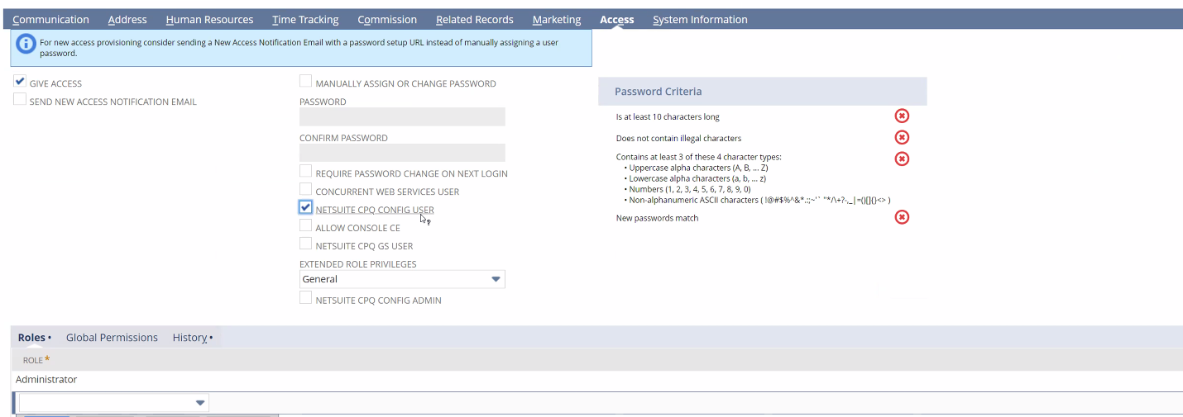
Give access and check netsuite cpq config user if you are user and also netsuite cpq config admin if you are admin.
Allow console ce

Permissions: admin and vcpq product builder.

SCPQ-Options
Configurator -> System ->

Enable external launch: website that is outsite of netsuite
Enable translation: show in different languages
Importar productos y exporter.

SCPQ-Product
New SCPQ-Product, crea un nuevo configurador con un nuevo producto.

Code tiene que ser sin espacios y alfa numéricos y capital letters.
Disabled: no va a mostrarse en la lista
Disabled cache: va a ser un poco mas rápido.
Check rules on every change: change the materials and data every time you press a button.
Load tables for actions: allowing reference tables to be loaded for scripts.

SCPQ-Material

X significa negación.
/ significa “is”.
X(A/1): If question A is not answer 1 then.

